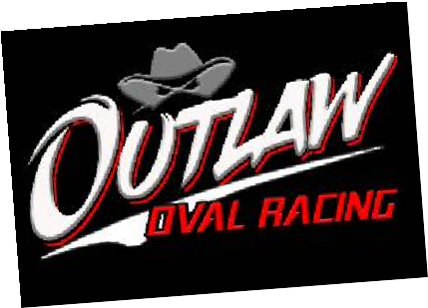 

OUTLAW 2025 ANNUAL RACING LICENCE APPLICATION FORM

Please complete every question in BLOCK CAPITALS using a blue/black ball point pen. Class of license required; Annual drivers license £70

Full Name of Applicant: .................................................................................Date of Birth: .............................

Address: .............................................................................................................................................................

Post Code: .............................Home Tel No.......................................Mob No...................................................

Email: ...........................................................................................

Racing Number in order of preference: 1 ................. 2 ................... 3 ................... Have you ever raced in any other formula? YES/NO (Delete one or the other)

If the answer is YES to the above, please list the formulas, dates and highest grades achieved:

............................................................................................................................................................................

**Please answer the following questions “YES” or “NO”**

1. Have you ever been refused a racing license by any other body or had a license withdrawn? ........
2. Are you dependent on any drugs that could affect your ability to drive/race? ........
3. Are you having treatment requiring medication that might affect your ability to drive/race? ........
4. Do you suffer any disorder of the heart or lungs? ........
5. Have you ever suffered injury to or had surgery or treatment to your neck or spine? ........
6. Are you physically handicapped by loss of limb or by any restriction of movement of limbs? ........
7. Do you suffer from epilepsy, fainting attacks or sudden giddiness? ........
8. Are you suffering from any mental illness or mental disability? ........
9. Is there any other reason or impediment that your ability to drive/race may be impaired? ........
10. Can you read a normal car number plate from a distance of 25 meters (with glasses if worn)? .......
11. Are you colour blind? ……..
12. I accept that while I am racing at any meetings, that I am responsible for all my party ……..
13. I accept that while licensed I’m bound by the Outlaw code of conduct and all in it. ........

If you have answered “Yes” to any of the first nine questions above, please give full details in the area below. You may also

continue on the reverse of this form if required.

**................................................................................................................................................................................**

DECLARATION: I declare that to the best of my knowledge the above answers are true. I have read, understood and agree to abide by the rules of Outlaw Oval Racing as issued by Outlaw Oval Racing Ltd. I further declare that I am fully aware that the sport of Outlaw Oval Racing is dangerous and agree that I shall take part in the sport of Outlaw Oval Racing entirely at my own risk. I further agree to save harmless and keep indemnified Outlaw Oval Racing Ltd, and respective directors, officials, members, landowners, promoters, servants, representatives and agents and/or drivers and mechanics from all actions, claims, cost, expenses and demands in respect of loss, death or injury to myself, howsoever caused, notwithstanding that the same may have contributed to, or occasioned by, the negligence of the several persons or bodies otherwise than in connection with the business or activities Outlaw Oval Racing Ltd, and further to keep indemnified the said parties in respect of death, injury or loss sustained by any third party as a result of the member is negligence and/or breach of contract, save in so far as in either event the said liability is covered by a policy of insurance.

**Applicants Signature: ......................................................... Date: ....................................................**

**Sign the above only if you have read and agree to declaration.** Please note that this application form will not be accepted or processed if not accompanied by a passport size photo and validated method of payment.

**Please return this form to:** Neil Pinkney. 37A Alexandria Dr, Darlington, DL2 1HG